The Cosmic Ray Spectrum at Ultrahigh Energies

M.I. Pravdin for Yakutsk Collaboration

Yu.G. Shafer Institute of Cosmophysical Research and Aeronomy, 31 Lenin Ave., 678980 Yakutsk, Russia

Estimation of EAS Energy by a Calorimetric Method

M.I. Pravdin for Yakutsk Collaboration

Yu.G. Shafer Institute of Cosmophysical Research and Aeronomy, 31 Lenin Ave., 678980 Yakutsk, Russia

A plan of the location of detector stations of the Yakutsk EAS Array

Station of Yakutsk EAS Array

The diagram of the trigger of the Yakutsk EAS array
Each trigger station has 2 scintillator detectors (S_{det}=2 m²). The coincidences within a resolving time 2.0 - 2.2 μs is required. EAS is selected when an event is registered simultaneously by three neighboring stations forming a triangle. Resolving time in this case equals 40 μs

Red triangles - trigger-500 (now - 63 cells, S_{II}=7.2 km²; up to 1992 - 19 cells S_{I} =2.5 km²)
Blue ones - trigger-1000 (now - 24 cells, S_{II} = 10.5 km²)
Green circle - 10 stations of the trigger-1000, working from 1973 up to 1990 (24 + 16=40 cells, S_{I} = 17.3 км²)

Estimation of shower energy E₀
The calorimetric method

The relation between parameters S₃₀₀ or S₆₀₀ and primary particle energy E₀ for EAS close to the vertical has been determined by the calorimetric method. For the average showers with different S₃₀₀ or S₆₀₀ E₀ is estimated as the sum separate a components:

E₀ = E_{i} + E_{el} + E_{μ}+ E_{μi} + E_{ν} + E_{h}

E_{i} = k⋅Φ is the energy lost by a shower over the observation level. It is estimated by measurements of total Cerenkov light flux Φ, and k = 2.16⋅10⁴ / (0.37 + 1.1⋅(X_{m} /1000)
in the interval of light waves 300-800 nm, In view of mean atmospheric transmittance.

E_{el} = 2.2⋅10⁶⋅N_{s}⋅λ_{N} is the energy conveyed below the array level. It is estimated by the attenuation length λ_{N} of the number of charged particles N_{s} through the atmosphere depth;

E_{μ} = ε_{μ}⋅N_{μ} is the energy of the muon component. It is estimated by the total number of muons N_{μ} and average energy on one muon ε_{μ} = 10.6⋅10⁹ eV

E_{μi} + E_{ν} = 0.76⋅E_{μ} is the energy of muons losses on ionization and the neutrino

E_{h} = 0.06⋅E_{i} is the energy on nuclear reactions in the atmosphere.

Red components are added on the basis of model calculation results.
For E₀ ≅ 10¹⁹ eV –
E_{i} / E₀ ≅ 74%;
E_{el} / E₀ ≅ 15%;
E_{μ} / E₀ ≅ 3.6%;
(E_{μi} + E_{ν} + E_{h}) / E₀ ≅ 7.4%
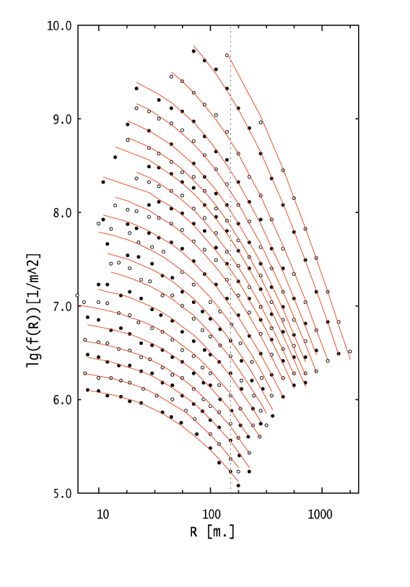

Lateral distribution of EAS Cerenkov light,

θ<30°, 10¹⁵ <E₀ < 3⋅10¹⁹ eV

The red lines correspond to approximation
Q(R) = Q₁₅₀⋅((62+R)/212)⁻¹⋅((200+R)/(350))^{1-m},
m = (1.15±0.05) + (0.30±0.06)⋅log(Q₁₅₀)
$$Φ=\int{2πR⋅Q(R)⋅∂R}$$

Interval of distances for real measurements of Cerenkov light in the average EAS

From lateral distribution and atmospheric transmittance - δΦ ≈ 12-15%
But we have a regular error connected to absolute calibration of cerenkov light detectors. It is ≅20%

We have the similar data on lateral distribution of the charged particles and muons

In result we have obtained:

E_{O} = (5.66 ± 1.4)⋅10¹⁷⋅(S₃₀₀(0°)/10)^{0.94 ± 0.02}

E_{O} = (4.6 ± 1.2)⋅10¹⁷⋅S₆₀₀(0°)^{0.98 ± 0.03}

2⋅10¹⁷ < E₀ <2⋅10¹⁹ eV

E_{O} = (5.66 ± 1.4)⋅10¹⁷⋅(S₃₀₀(0°)/10)^{0.94 ± 0.02}

Ratio between shower energy E₀ and S₃₀₀(0º) determined by the calorimetric method

E_{O} = (4.6 ± 1.2)⋅10¹⁷⋅S₆₀₀(0°)^{0.98 ± 0.03}
Ratio between shower energy E₀ and S600(0º) determined by the calorimetric method

Zenith-Angular Dependence of S₃₀₀ and S₆₀₀

We assume that S300 (S600) dependence on the atmospheric depth must be described as
S(θ) = S(0º)·{(1-β)·exp((X₀-X)/λ_{E}) + β·exp((X₀-X)/λ_{M})}
X₀ = 1020 g·cm⁻², X=X₀/cos(θ)
λ_{E} = 200 g·cm⁻², λ_{M} = 1000 g·cm⁻²
β is a portion of the «muon» component in the total response of S(0º) at the depth of X₀ = 1020 g·cm⁻²

for S₃₀₀
β₃₀₀ = (0.368 + 0.021)⋅(S₃₀₀(0º)/10)^{–(0.185 + 0.02)}
β₃₀₀ = (0.33 + 0.017) ·(E₀/10¹⁸) ^{–(0.19 + 0.02)}

for S₆₀₀
β₆₀₀ = (0.62 + 0.06) ·S₆₀₀(0º)^{–(0.076 + 0.03)}
β₆₀₀ = (0.58 + 0.05) ·(E₀/10¹⁸)^{–(0.077 + 0.03)}

S₃₀₀ versus the atmospheric depth X for different energies. Black indices (S1 - S7) are equi-intensity method data, blue indices (Q1 - Q6) are data by Q₄₀₀ method. The lines are the change of S₃₀₀ depending on X by using formula

β₃₀₀ versus the showers energy. β₃₀₀ is a portion of the hard component in the total response of S₃₀₀(0º) at the depth of 1020 g·cm⁻²

S₆₀₀ versus the atmospheric depth X for different energies. Black indices (S1 – S5) are equi-intensity method data, blue indices (Q1 – Q4) are data by Q₄₀₀ method. The lines are the change of S₆₀₀ depending on X by using formula

Largest events
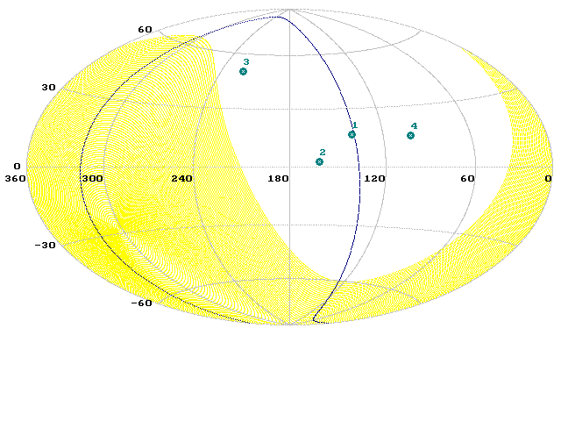

Differential Energy Spectrum at E₀ > 10¹⁷ eV

Integral Energy Spectrum of the Yakutsk Array

Last largest Event

Comparison of the Yakutsk array Spectrum with accounts from AGN
Berezinsky V.S., Gazizov A.Z., Grigorieva S.I. // preprint 2002, hep-ph/0204357

The conclusion. The Spectrum obtained on the Yakutsk array will be agree with the assumption, that the particles with E₀ > 10¹⁹ eV are mainly formed in extragalactic sources

