- Identification of possible UHECR sources
II. Spectra at the Earth at E≥5⋅10¹⁹ eV from identified sources

A.V.Uryson

Lebedev Physics Institute

- Identification of possible UHECR sources

Assumptions of the identification procedure: EAS at E>4⋅10¹⁹ eV

1) are of extragalactic origin;
- CR sources are astrophysical objects
Seyferts, BL Lac’s, radiogalaxies, X-ray pulsars (as most powerful)
3) CR propagate along straight lines.

IDENTIFICATION PROCEDURE
EAS with errors in arrivals in equatorial coordinates Δα3⁰, Δδ3⁰ .
Objects were searched in 1-, 2-, 3-error boxes around the axis of EAS.

“Avoidance zone” : at low galactic latitudes gas & dust make it difficult
to observe objects → lack of objects in catalogues→
EAS were subdivided into groups depending on galactic latitude b.

Each group contains K showers, N of them have objects of a given type in error-boxes.
Statistics of EAS: 17 AGASA 1996
51 AGASA (48), HP (1), Yakutsk (4) 1996-99
63 AGASA (58), HP (1), Yakutsk (4) 2000-2004

Is it by chance or not?

MC arrivals, K_{sim}=K, N_{sim} have objects in error-boxes.
The probability of chance occurence M
P=Σ (N_{sim})_{i}/M, M=10⁵- trials.
i=1

Results:
Seyfert nuclei at z≤0.0092 (Uryson 1996-2004)
BL Lac’s (Uryson 2000-2003; Gorbunov et al. 2002)

The probabilities of random occurence of objects in error-boxes of EAS arrivals
All nearby Seyferts:
63 showers, P₁ (16)=1.1⋅10⁻³, P₂ (27)=3.6⋅10⁻⁴, P₃ (29)=2.4⋅10⁻²;
54 showers with |b|>11.2⁰ P₁ (16)=1.2⋅10⁻³, P₂ (26)=6.5⋅10⁻⁴, P_{3 (29)=1.8(10-2;}
37 showers with |b|>21.90 P1 (13)=3.2(10⁻³, P₂ (23)=1.8⋅10⁻⁴, P₃ (23)=2.5⋅10⁻²;
27 showers with |b|>31.7⁰ P₁ (14 )=5.1⋅10⁻⁴, P₂ (23)=2.0⋅10⁻⁵, P₃ (23)=9.5⋅10⁻³.
Nearby Seyferts having detailed classification:
63 showers, P₁(12)=1.1⋅10⁻², P₂ (23)=3.2⋅10⁻³, P₃ (27)=3.2⋅10⁻²;
54 showers with |b|>11.2⁰ P₁(12)=1.5⋅10⁻², P₂ (22)=5.2⋅10⁻³, P₃ (27)=2.3⋅10⁻²;
37 showers with |b|>21.9⁰ P₁(9)=3.0⋅10⁻², P₂ (19)=3.0⋅10⁻³, P₃ (21)=3.7⋅10⁻²;
27 showers with |b|>31.7⁰ P₁(10)=1.0⋅10⁻², P₂ (19)=1.1⋅10⁻³, P₃ (21)=2.2⋅10⁻².
Confirmed, probable or possible BL Lac’s:
63 showers P₁ (45)<4⋅10⁻⁵, P₂ (56)=6.⋅10⁻⁵, P₃ (57)=2.3⋅10⁻²;
54 showers with |b|>11.2⁰ P₁ (42)<3.⋅10⁻⁵, P₂ (51)=3.4⋅10⁻⁴, P₃ (51)=1.0⋅10⁻¹;
37 showers with |b|>21.9⁰ P₁ (36)<4.⋅10⁻⁵, P₂ (36)=2.5⋅10⁻³, P₃ (36)=8.7⋅10⁻²;
27 showers with |b|>31.7⁰ P₁ (27 )<4.⋅10⁻⁵, P₂ (27)=5.2⋅10⁻², P₃ (27)=4.5⋅10⁻¹.
Confirmed BL Lac objects:
63 showers, P₁(38)<1.⋅10⁻⁵, P₂ (48)=4.7⋅10⁻⁴, P₃ (53)=1.0⋅10⁻²;
54 showers with |b|>11.2⁰ P₁(42)<3.⋅10⁻⁵, P₂ (43)=6.9⋅10⁻³, P₃ (47)=7.5⋅10⁻²;
37 showers with |b|>21.9⁰ P₁(28)<3.⋅10⁻⁵, P₂ (33)=1.8⋅10⁻³, P₃ (35)=4.0⋅10⁻²;
27 showers with |b|>31.7⁰ P₁(24)<1.⋅10⁻⁵, P₂ (26)=1.2⋅10⁻², P₃ (27)=2.0⋅10⁻¹.

Radiogalaxies, X-ray pulsars: ~0.01-0.1.
Two problems: Seyferts are of low luminosity
BL Lac’s are at z≤0.35 – very distant (GZK –cut off)

UHECR acceleration in the identified sources

Seyferts with low luminosity: (Uryson 2001; 2004)
acceleration in weak jets by colisionless shocks → initial spectra ~E^{-χ}

BL Lac’s (powerful jets): (Kardashev 1995)
acceleration in superstrong electric field → initial spectra monoenergetic

- Spectra at the Earth at E≥5⋅10¹⁹ eV from identified sources

Assumptions:

- CR: protons
initial spectra: ~E^{-χ} or monoenergetic, E=10²¹ eV

- Seyferts & BL Lac’s from Veron 2001

- pγ→N+π (e⁺e⁻ production is small)
σ(ε*), K(ε*) – from (Stecker, 1968; Particle Data Group 2002)
ε* - photon energy in proton system

relic photons: Planck distribution, T=2.7 K
<ε>=6⋅10⁻⁴ eV, <n>=400 cm⁻³
energetic “tail” <ε_{t}>=10⁻³ eV, <n_{t}>=42 cm⁻³

IR photons: n(ε)=7⋅10⁻⁵⋅ε^{-2.5} (cm⁻³ eV⁻¹)
ε≈2⋅10⁻³ – 0.8 eV (Puget et al. 1976, Stecker 1998)

4) adiabatic losses -dE/dt=H(1+z)^{3/2} H-Hubble constant
- cosmological evolution (Einstein-de Sitter model, Ω=1)
t= 2/3 (c/H) (1+z)^{-3/2}, r=2/3 (c/H) [1-(1+z)^{-3/2}]

MC simulation of CR propagation
from the source to Earth
energy losses as above
z-distributions of sources in accordance with Veron 2001

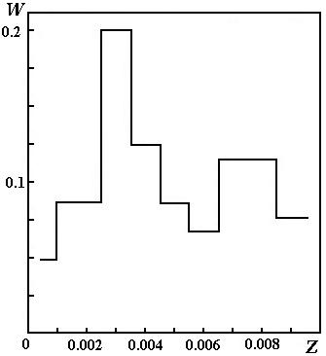
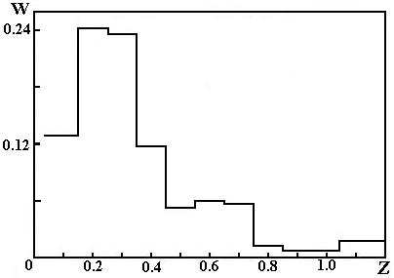

z-distribution of Seyferts z-distribution of BL LAC’s

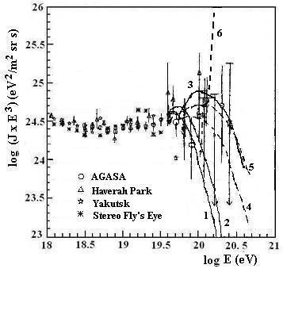
Differential energy spectrum of cosmic rays determined by the arrays Haverah Park, Yakutsk, Fly’s Eye, AGASA [2]. Curves are calculated UHECR spectra from identified sources: BL Lac’s (solid lines), (1)– the initial spectrum is exponential with χ=3.0, (2) - the initial spectrum is exponential with χ=2.6, (3) - the initial spectrum is monoenergetic; nearby Seyferts (dashed lines): (4)– the initial spectrum is exponential with χ=3.0, (5) - the initial spectrum is exponential with χ=2.6, and (6) - the initial spectrum is monoenergetic.

Nearby Seyferts, distant BL LAC’s:
similar spectra close to the measured one.

This confirms the initial spectra:
~E^{-χ} in nearby Seyferts, monoenergetic in distant BL LAC’s.
Luminosity of identified sources in CR

Seyferts:
L_{CR}≈10⁴² erg/s, χ=3.0 Uryson 2001

L_{CR}≈10⁴³ erg/s, χ=3.1 Uryson 2004

Energy balance for BL LAC’s

(U_{S})_{CR}=U_{CR} - total energy of sources in CR=total energy of CR
(U_{CR})_{MEASURED} – UHECR energy measured in experiments
(U_{CR})_{LOST} - UHECR energy lost in extragagalactic space

(U_{S})_{CR}=(U_{CR})_{MEASURED} + (U_{CR})_{LOST} =U_{CR}

L_{CR}≈ (U_{CR})/(T⋅N) T – time of CR life, N – number of sources

10²¹ eV
(U_{CR})_{MEASURED}= ∫ I(E)EdE ⋅4π/c⋅V
5⋅10¹⁹ eV

V – volume filled by CR, radius r≈900 Mpc:

T≈2⋅10¹⁷ s
N≈100 (Veron 2001)

CR initial energy 10²¹ eV, CR energy at the Earth 5⋅10¹⁹ eV →
(U_{CR})_{MEASURED} ≈0.05U_{CR}

BL LAC’s:
L_{CR}≈10⁴⁶ erg/s – upper limit

CONCLUSION

Both nearby Seyferts and distant BL LAC’s produce similar spectra at the Earth, if initial spectra are: ~E^{-χ} in Seyferts, monoenergetic in BL LAC’s.
The maximal energy in CR: 10²¹ eV.
E>5⋅10¹⁹ eV: no GZK-cut off.
CR - luminosities of identified sources are appropriate.

