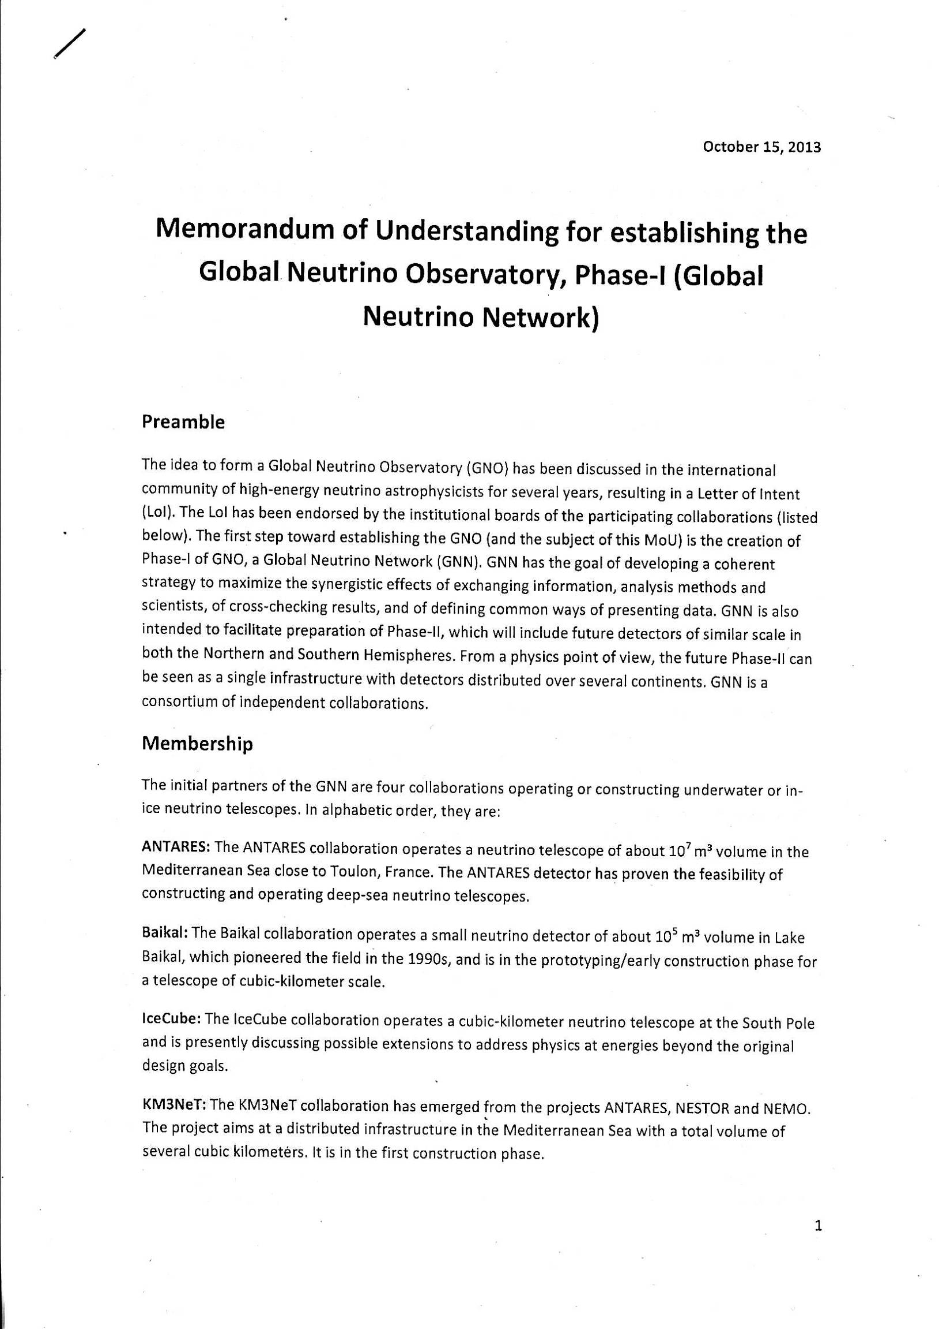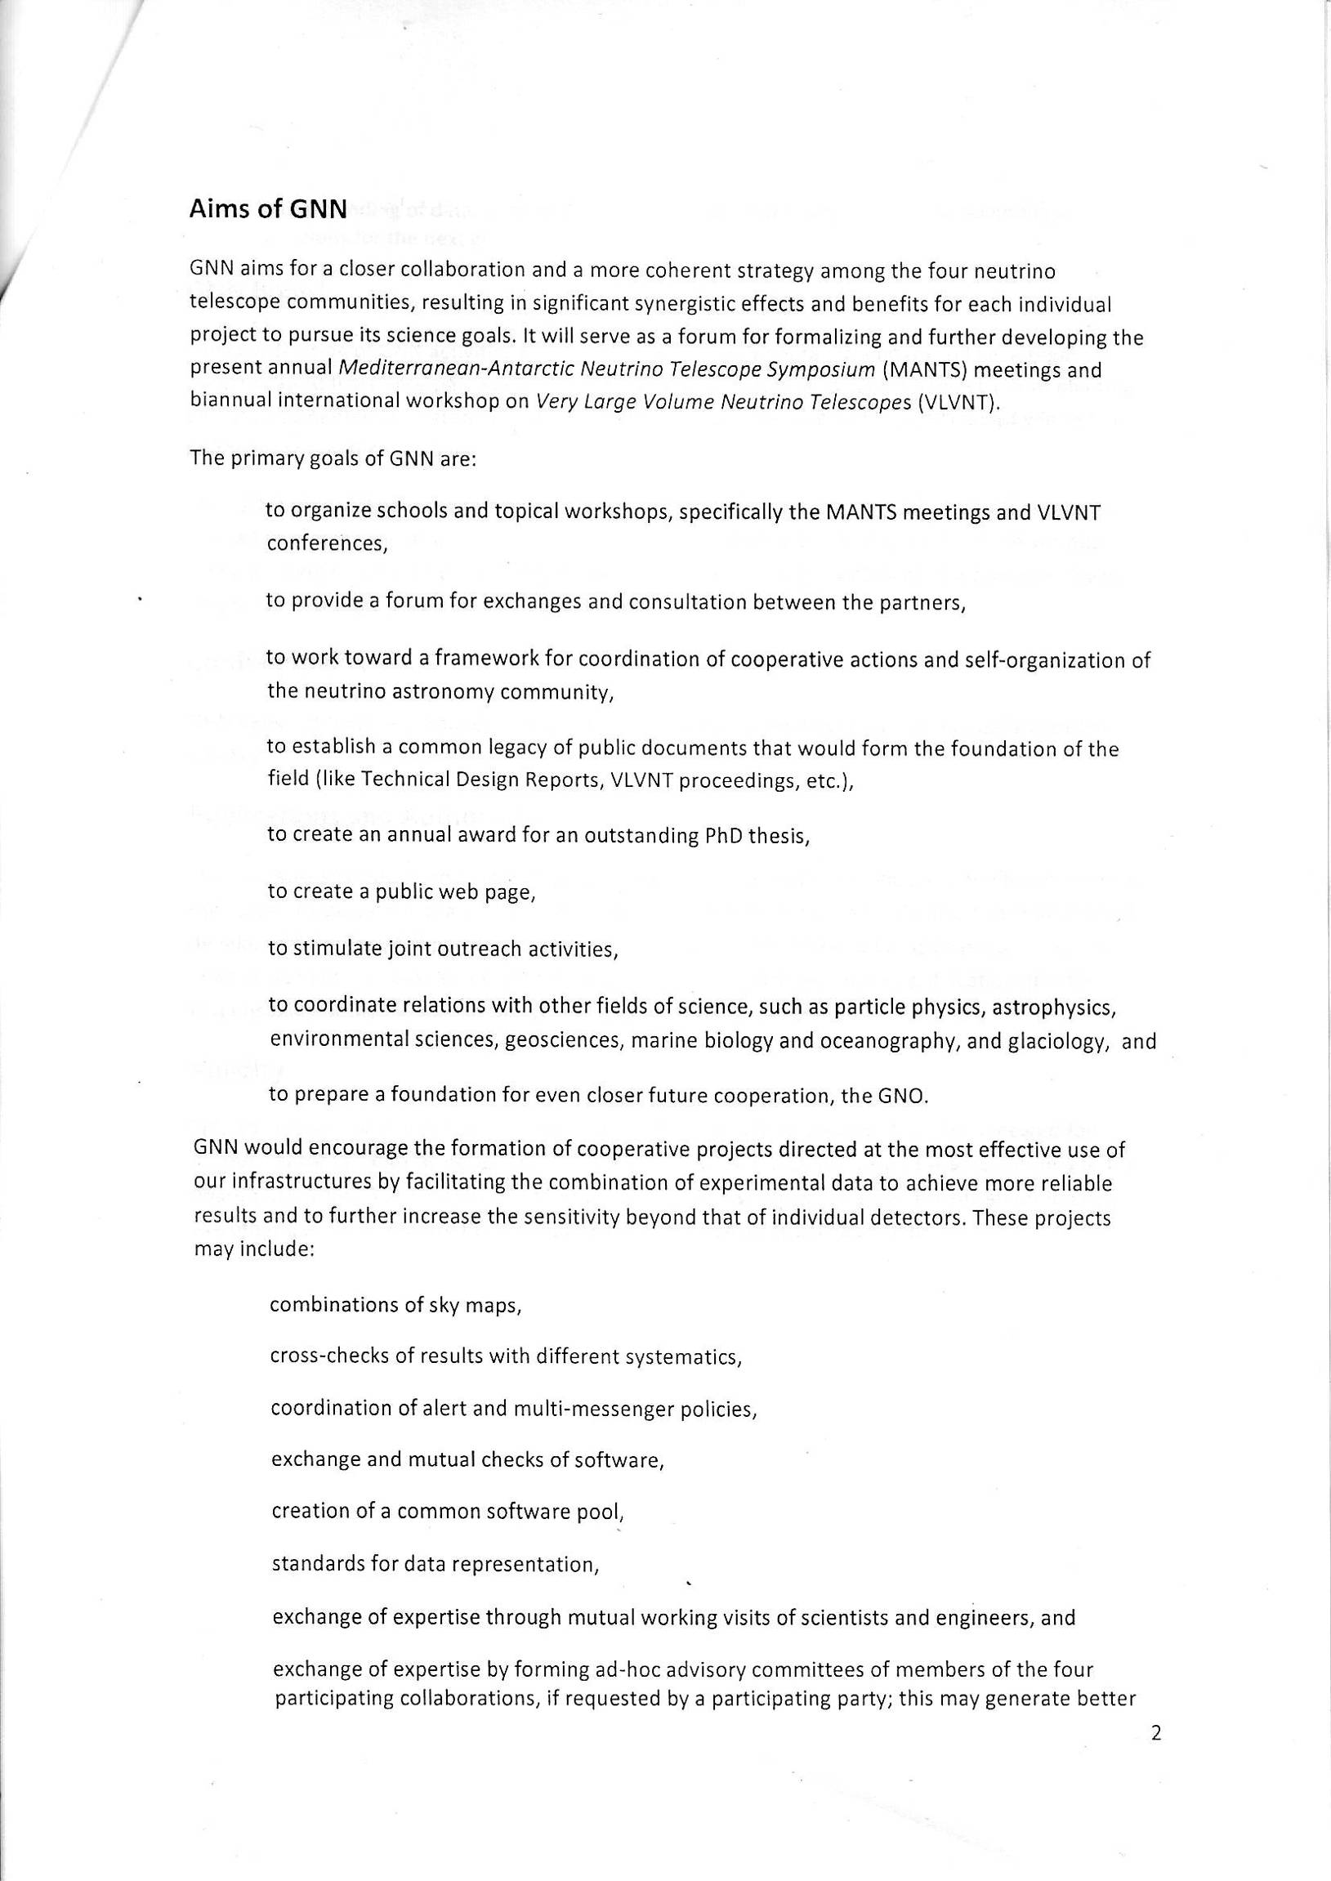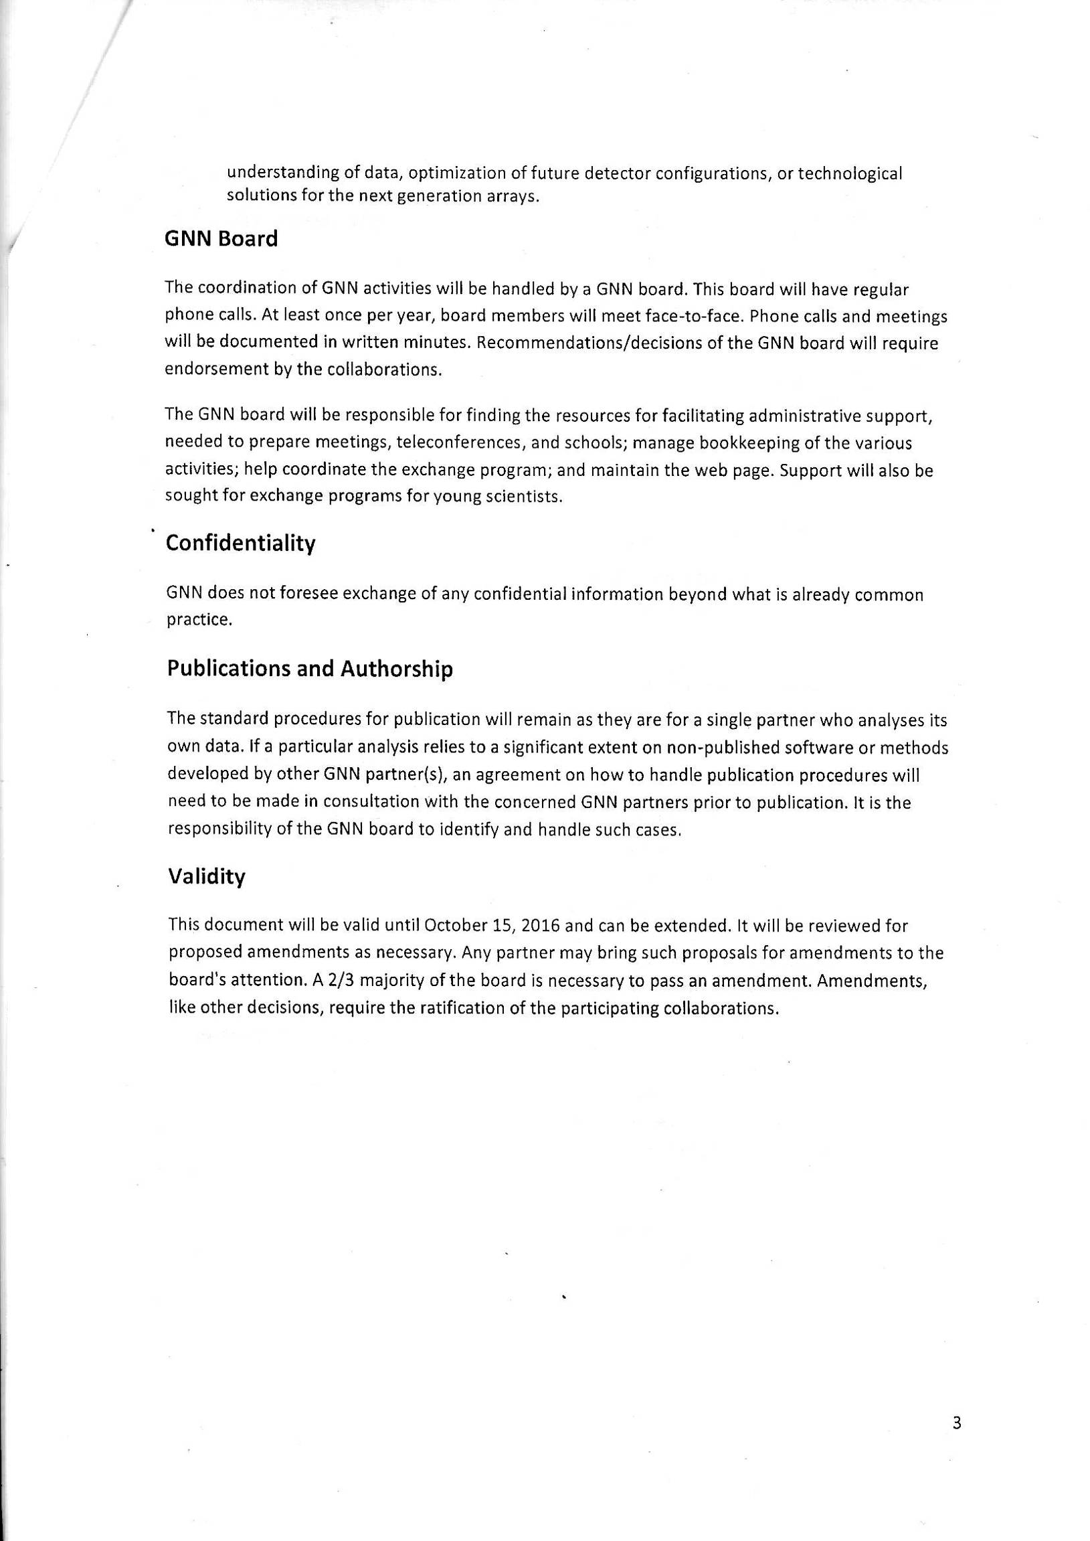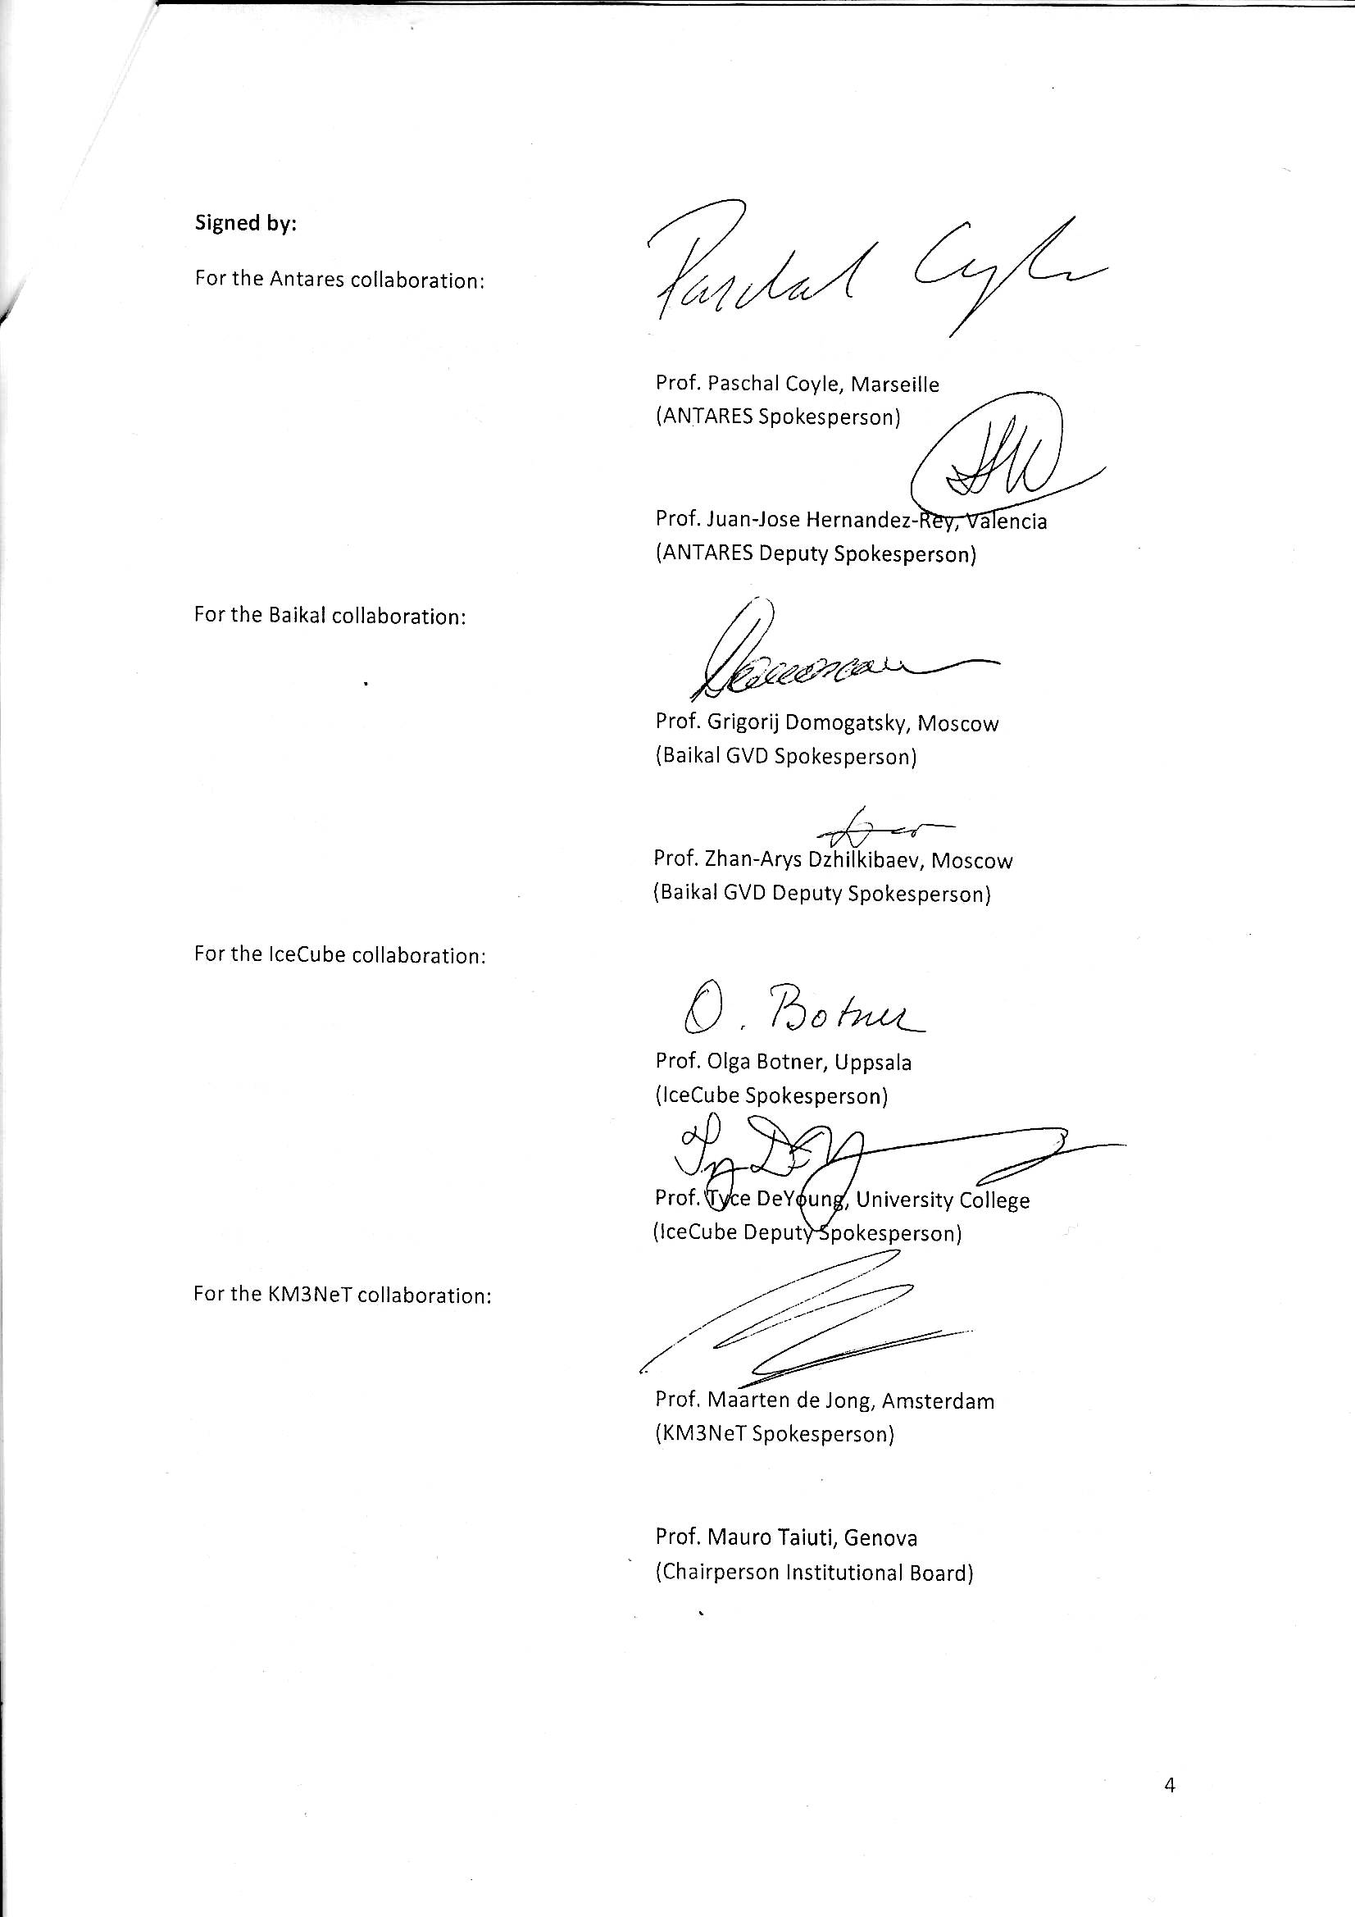
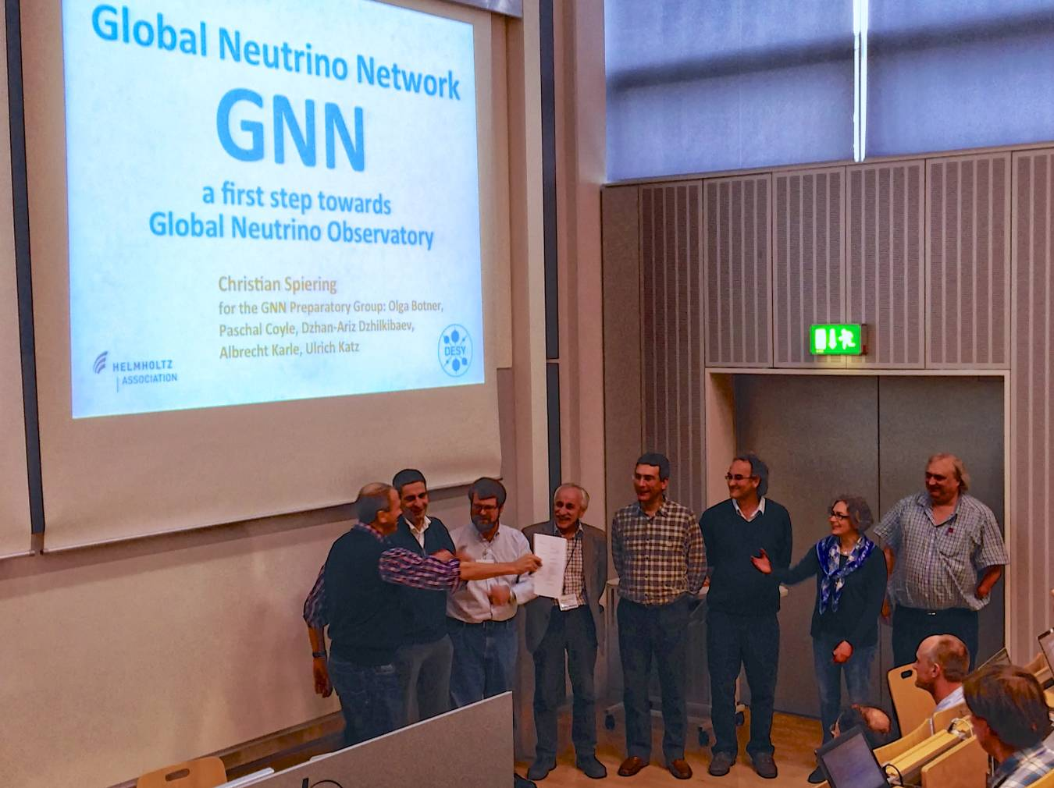
October 15, 2013. München. MoU signing.

From left to right: Christian Spiering, Maarten de Jong, Tyce DeYoung, Zhan.-Arys Djilkibaev,
Juan-Jose Hernandez-Rey, Paschal Coyle, Olga Botner, Uli Katz.

